**Class Diagrams**

For each game object we will be using classes to incorporate them into the scene, below demonstrates the exact implementation planned for each class:

**Weapons:**

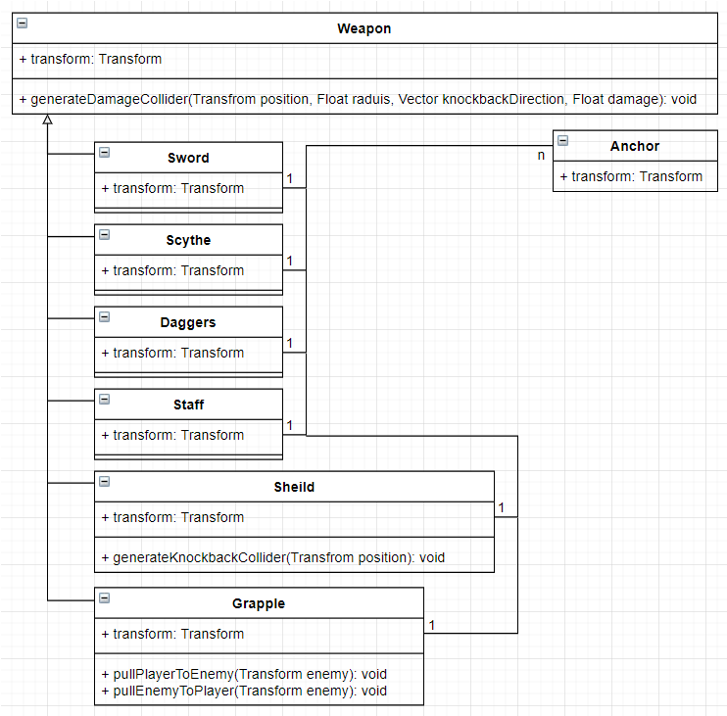

Figure - Class Diagram for player weapons